The Title Goes Here with Each Initial Letter Capitalized

Author’s Name1,1, a)* Author’s Name2,1, b) and Author’s Name32, 3, c)

1Replace this text with an author’s affiliation (department, university / institution, country)

2Second affiliation (department, university / institution, country)

3Third affiliation (department, university / institution, country) (if applicable)

a)*Corresponding author: first.author@institution.edu

b)E-mail: second.author@institution.edu

c)E-mail: third.author@institution.edu

**Abstract.** This template has been designed for full paper of YRQS 2022 Symposium. Your manuscript must be submitted to Easychair submission system. Full paper submissions are due by January 4, 2022. A concise and factual abstract is required. The abstract should state briefly introduction, the purpose of the research, methodology, expected results / results and conclusions. An abstract is often presented separately from the article, so it must be able to stand alone. For this reason, References should be avoided, but if essential, then cite the author(s) and year(s). Also, non-standard or uncommon abbreviations should be avoided, but if essential they must be defined at their first mention in the abstract itself.

**Keywords:** Instructions, Paper template, YRQS2022 (max 5 keywords - Keywords here should be separated by commas).

# first, second, and third level headings (first level heading) (Use the Microsoft Word template style: Heading 1)

This document was prepared using the proceedings template for Microsoft Word. It provides a simple example of a paper and offers guidelines for preparing your article. Here we introduce the paragraph styles for Level 1, Level 2, and Level 3 headings. Please note the following:

* In this template we note whether each heading is Level 1, 2, or 3 – for example, “(Second Level Heading).” This is for guidance only; your article headings will, of course, not need those notations.
* Under each heading we have noted which paragraph style to use – for example, “(Use the Microsoft Word template style: Heading 2).” Again, those notes are not part of the headings. Their purpose is to advise you of the name of the style defined in the proceedings Word template.

To format a paragraph, use the Microsoft Word template style: *Paragraph*.

**Do not include any headers, footers, or page numbers in your document.**

## How to Apply the Template Paragraph Styles (Second Level Heading) (Use the Microsoft Word template style: Heading 2)

Here is how todisplay a pop-up window from which to select and apply the proceedings template paragraph styles:

|  |  |
| --- | --- |
| Click here to display the Styles window – making it easy to choose and apply the proceedings template styles.  To apply a style to a paragraph, click anywhere in the paragraph text then click on the appropriate style listed in the Styles window. |  |

## How to Use this Template (Second Level Heading) (Use the Microsoft Word template style: Heading 2)

You can edit or delete the content provided in this template and replace it with the text and figures of your article. Please be sure you do not accidentally leave any of this text as part of your paper!

## Heading with Each Initial Letter Capitalized (Second Level Heading) (Use the Microsoft Word template style: Heading 2)

Apart from prepositions and articles, all words in second and third level headings should have their initial letters in uppercase. Prepositions are words like “for,” “from,” “with,” “in,” “off,” and articles include words such as “an,” “a,” “the.”

This is the paragraph spacing that occurs when you use the [ENTER] key.

### Heading with Each Initial Letter Capitalized (Third Level Heading) (Use the Microsoft Word template style: Heading 3)

As with first and second level headings, all words except prepositions and articles (see above) should appear with initial letters in uppercase.

This is the paragraph spacing that occurs when you use the [ENTER] key.

# mathematics (first level heading) (Use the Microsoft Word template style: Heading 1)

Here we provide some basic advice for formatting your mathematics, but we do not attempt to define detailed styles or specifications for mathematical typesetting. You should use the standard styles, symbols, and conventions for the field/discipline you are writing about.

## A Note on Microsoft Word’s Equation Editors (Second Level Heading) (Use the Microsoft Word template style: Heading 2)

From Word 2007 onwards, Microsoft Word provides two “Equation Editors,” which, for ease of reference, we’ll call “Old Style Equations” and “New Style Equations.”

* **“New Style Equations”** (Word 2007 onwards): With Word 2007 Microsoft introduced a powerful new built-in Equation Editor that enables input of sophisticated mathematics typeset (usually) in the Cambria Math font. You access it from the Insert menu.
* **“Old Style Equations”** (Word 97–Word 2003): For versions of Microsoft Word between Word 97 and Word 2003, mathematical input was created by an add-in: Inserting and editing a “Microsoft Equation 3.0 object,” typically by *Insert* ⇨ *Object* and selecting “Microsoft Equation 3.0.”

Newer versions of Microsoft Word (Word 2007 and onwards) still support the original “Old Style Equations” method of creating mathematics by inserting an equation via *Insert* ⇨ *Object* and selecting “Microsoft Equation 3.0.”

## Which Microsoft Word Equation Editor Should I Use? (Second Level Heading) (Use the Microsoft Word template style: Heading 2)

Due to technical requirements of OpenType font technology, Microsoft Word’s “New Style” Equation Editor works only with fonts specially designed for mathematical typesetting. Unless you have obtained and configured new OpenType math fonts, it is highly likely that your installation of Word will use the Cambria Math font for all mathematics created with the “New Style” editor. Using the Cambria Math font for mathematics and Times Roman for your text will cause a mismatch in the visual appearance of your article, so, for consistency, we prefer authors to use the “Old Style” Equation Editor because it is straightforward to amend the size/style of the fonts it uses.

## Formatting and Inserting Equations (Second Level Heading) (Use the Microsoft Word template style: Heading 2)

Equations should be centered with equation numbers on the right-hand side (flush right). Achieving a pleasing layout of equations can be tricky in Microsoft Word, so here are some tips. You can either:

1. Copy, paste, and edit the sample equation provided (recommended), or
2. Manually insert an equation and equation number

### Copy, Paste, and Edit a Sample Equation (Third Level Heading) (Use the Microsoft Word template style: Heading 3)

To use this “Old Style Equation” as a “template,” highlight the entire line, then use cut and paste to the new location. Note that the equation number will automatically update (increment).



### Manually Inserting an Equation and Equation Number (Third Level Heading) (Use the Microsoft Word template style: Heading 3)

If you prefer to manually insert and number equations, follow this step-by-step guide:

1. Make sure you can see “hidden characters” by switching on “show invisibles” from the Home menu (it looks like this: ). This allows you to see paragraph markers (¶) and tab characters (🡪), which are usually hidden from view.
2. Create a blank paragraph by pressing [ENTER].
3. Format your new blank paragraph by applying the Microsoft Word template style: *Equation.* The *Equation* paragraph style sets up the tabs so that you can center the equation and have an equation number appear at the right.
4. Place your cursor at the start of your new paragraph and press the [TAB] key twice.
5. Place your cursor between the tab characters (🡪) and insert your equation using *Insert* ⇨ *Object* ⇨ *Microsoft Equation 3.0*.
6. To add an equation number, place your cursor at the end of the paragraph (just before the paragraph markers (¶) and after the second tab character (🡪)).
7. On the *Insert* tab, in the *Text* group, click *Quick Parts* and then click *Field*:

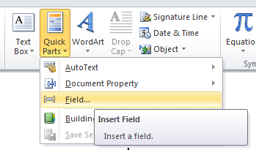

1. A dialog box should appear:

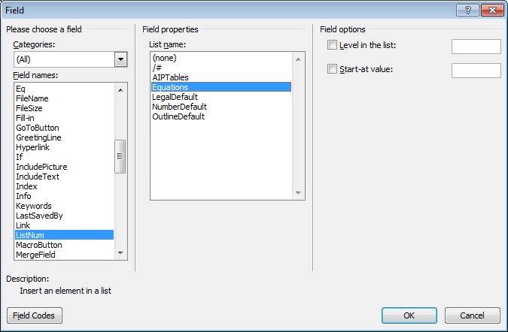

1. From the list of *Field Names* on the left of the dialog box, select *ListNum.*
2. From the list of *Field properties* on the right, select the “Equations” *List name* and click OK. You should now see an equation number in parentheses: e.g., (3).

# OTHER SPECIFICATIONS (first level heading) (Use the Microsoft Word template style: Heading 1)

Figures, tables, and equations must be inserted in the text and may not be grouped at the end of the paper. Important: A miscount of figures, tables, or equations may result from revisions. Please double check the numbering of these elements before you submit your paper to your proceedings editor.

## Figures (Second Level Heading) (Use the Microsoft Word template style: Heading 2)

If you need to arrange a number of figures, a good tip is to place them in a table, which gives you additional control of the layout. Leave a line space between your figure and any text above it, like this one:

|  |  |
| --- | --- |
|  |  |
| (a) | (b) |

**Figure 1.** To format a figure caption use the Microsoft Word template style: *Figure Caption*. The text “**FIGURE 1,**” which   
labels the caption, should be bold and in upper case. If figures have more than one part, each part should be labeled (a), (b), etc. Using a table, as in the above example, helps you control the layout

Cite all figures in the text consecutively. The word “Figure” should be spelled out if it is the first word of the sentence and abbreviated as “Fig.” elsewhere in the text. Place the figures as close as possible to their first mention in the text at the top or bottom of the page with the figure caption positioned below, all centered. Figures must be inserted in the text and may not follow the Reference section. Set figure captions in 9 point size, Times Roman font. Type the word “**FIGURE 1**.” in bold uppercase, followed by a period.

### Color Figures (Third Level Heading) (Use the Microsoft Word template style: Heading 3)

Authors are welcome to use color figures within their article.

## Tables (Second Level Heading) (Use the Microsoft Word template style: Heading 2)

Due to the wide range and complexity of tables, we simply offer an example for guidance. Please follow the style for table (and figure) captions.

|  |  |  |
| --- | --- | --- |
| **TABLE 1.** To format a table caption, use the Microsoft Word template style: *Table Caption*. The text  “**TABLE 1**” which labels the caption, should be bold and all letters capitalized. Center this text above the Table. Tables should have top and bottom rules, and a rule separating the column heads from the rest of the table only. | | |
| **Column Header Goes Here** | **Column Header Goes Here** | **Column Header Goes Here** |
| Row Name Here | x | x |
| Row Name Here | x | x |
| Row Name Here | x | x |

## Font Embedding (Second Level Heading) (Use the Microsoft Word template style: Heading 2)

As the author and creator of your article PDF, you have the most intimate knowledge of exactly what the PDF should display.

### Why Should I Care About Font Embedding? (Third Level Heading) (Use the Microsoft Word template style: Heading 3)

# Acknowledgments (Use the Microsoft Word template style: Heading 1)

This research was supported by the Ministry of Higher Education (MoHE) of Malaysia through Fundamental Research Grant Scheme (FRGS/1/2020/xxxxx/UUM/02/5/2). We also want to thank the Universiti Utara Malaysia (UUM) for the facilities provided.

# References (Use the Microsoft Word template style: Heading 1)

**Citation in text**

In-text citations and references must be formatted using the American Psychological Association (APA) 7th Edition. APA in-text citation style uses the author's last name and the year of publication. References, only of works cited, should be listed in full at the end of the paper arranged alphabetically. Please ensure that every reference cited in the text is also present in the reference list (and vice versa). Unpublished results and personal communications are not recommended in the reference list, but may be mentioned in the text. You may use Mendeley as a Reference Manager.

Please use APA 7th edition referencing style. For examples of APA formatting issues and frequently asked questions, follow the <https://apastyle.apa.org/style-grammar-guidelines/references/examples/journal-article-references>